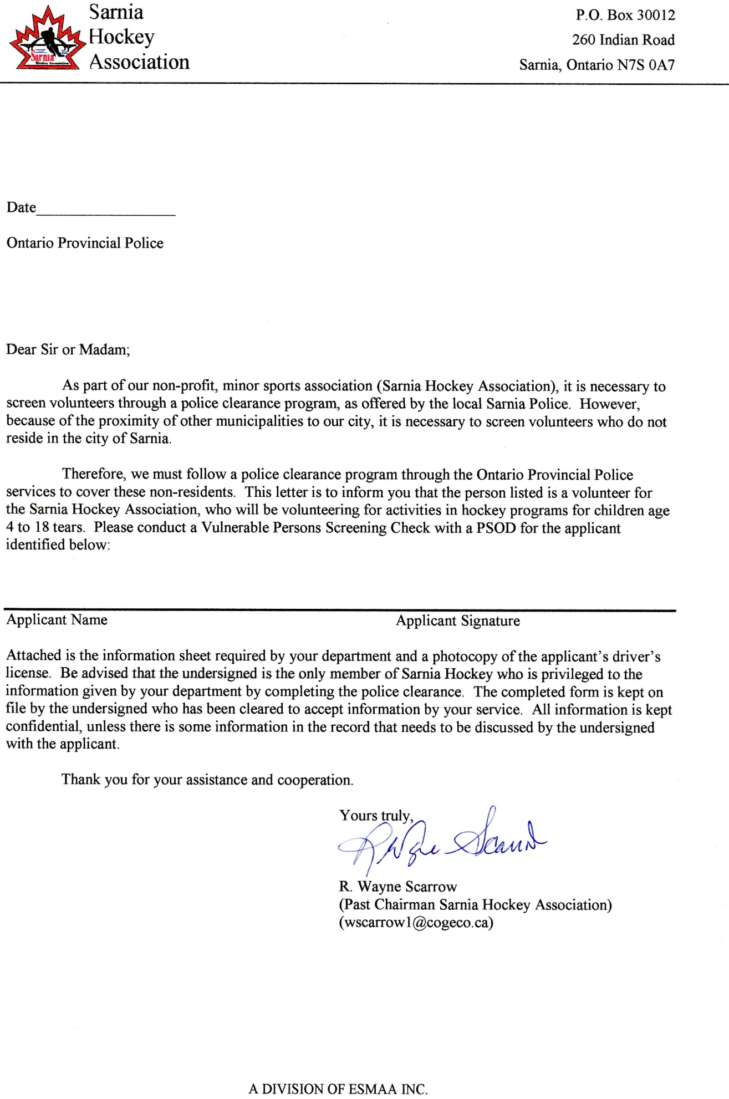

Contact Phone Number 519 542-4860