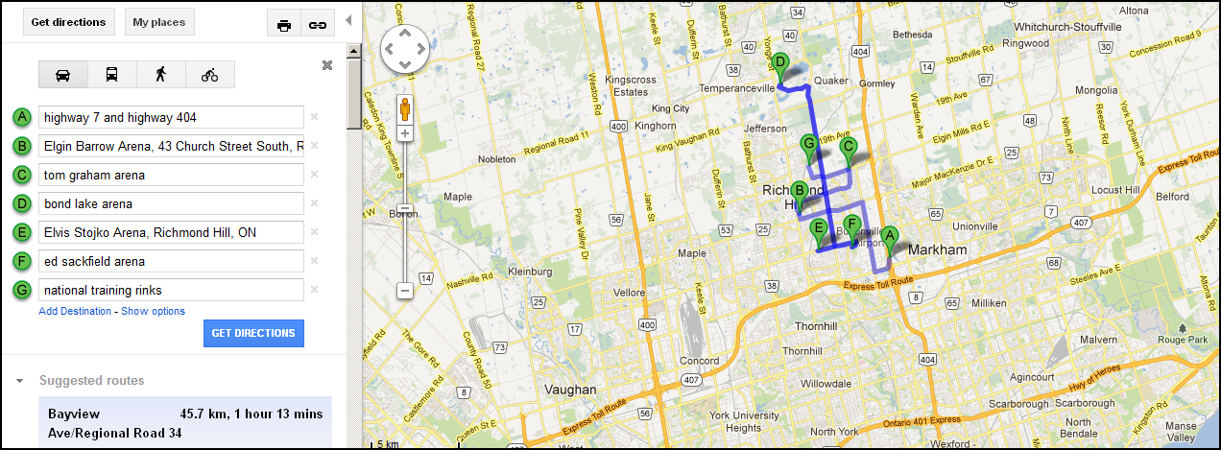

A = approximate area for cluster of hotels (@ Hwy 7 and Hwy 404)
B through G = Arenas
Red Square = Richmond Hill
Blue Square = Markham
Yellow Square = Vaughan

